ARTH 345 Spring 2021
Test 3

Due: Saturday, April 10, 5 pm
Submission:
- Please type and save your document in Microsoft Word or rtf format (you can type directly onto the Word version of the test if you wish).
- Go to Blackboard.
- Click on “Assessments” on the menu on the left.
- Click on “Test 3” folder.
- Click on “ARTH 345 test 3” assignment and follow the instructions to upload your document.

Please complete both parts for full credit

Part 1. Three short answer questions (2 points each). Two or three sentences should be sufficient for each answer.

Question 1. Explain what a militia company (or civic guard) is in a 17th-century Dutch city.

Questions 2 and 3 relate to this image.
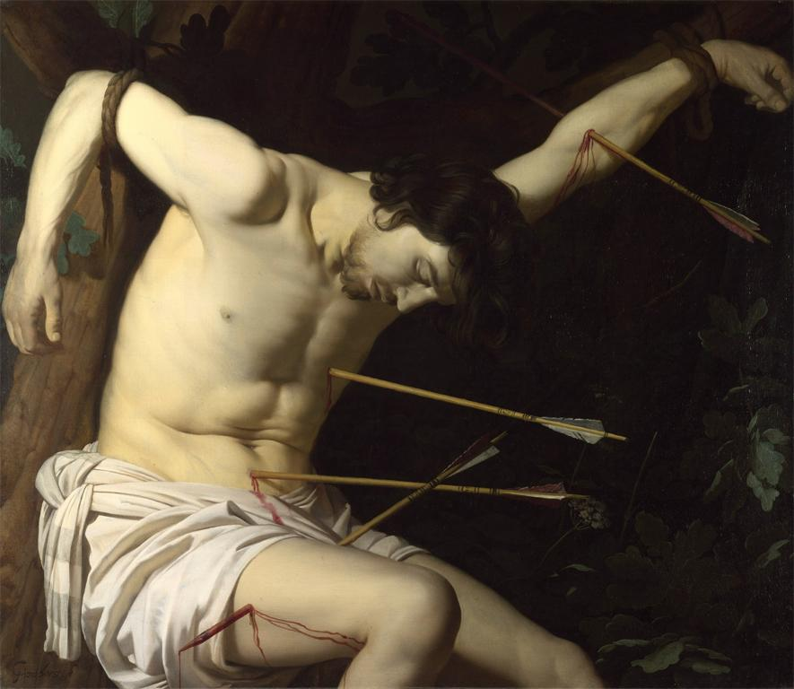
Gerrit van Honthorst, St. Sebastian, c. 1623

Question 2.
Gerrit van Honthorst is known as one of the “Caravaggisti,” i.e., an artist who adapted the style of Caravaggio—an Italian painter from the turn of the 17th century—in his own art. Name two characteristics in this painting that would explain that label.

Question 3.
The Dutch Republic’s official religion was Calvinism, which opposed the use of images of saints in worship. Why was Gerrit van Honthorst able to make this painting of St. Sebastian, which was a Catholic subject?

Part 2. Three single-image essay questions (20 points each). Each of your answers should be about 150 – 200 words in length.
Question 1
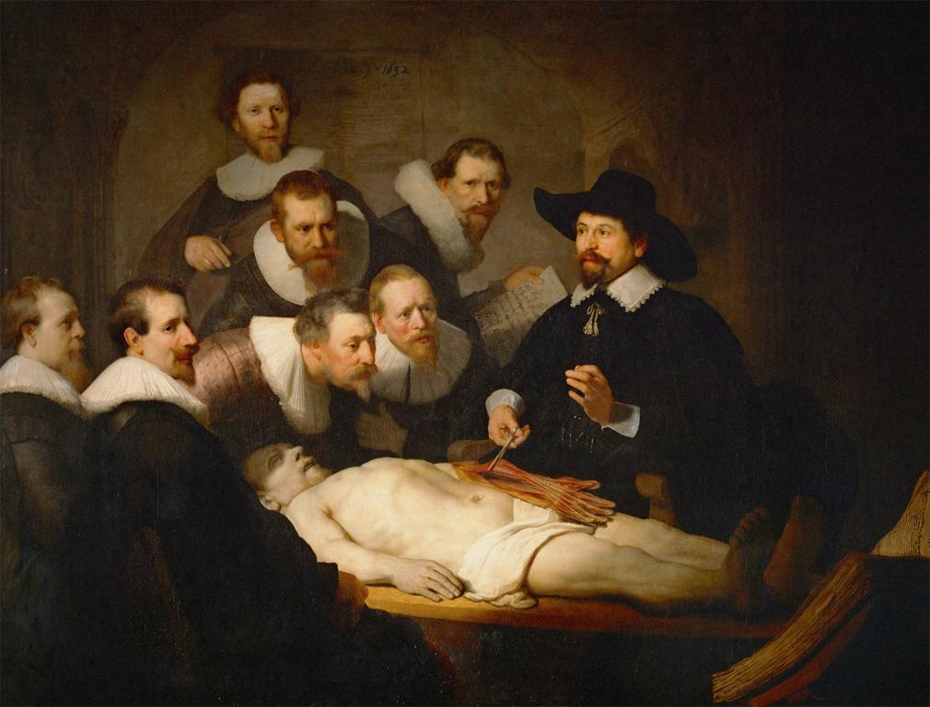
Rembrandt, Anatomy Lesson of Dr. Nicolaes Tulp, 1632.
Who were the group depicted in this painting? How did Rembrandt transform a distinctively Dutch form of portraiture in this painting?

Question 2

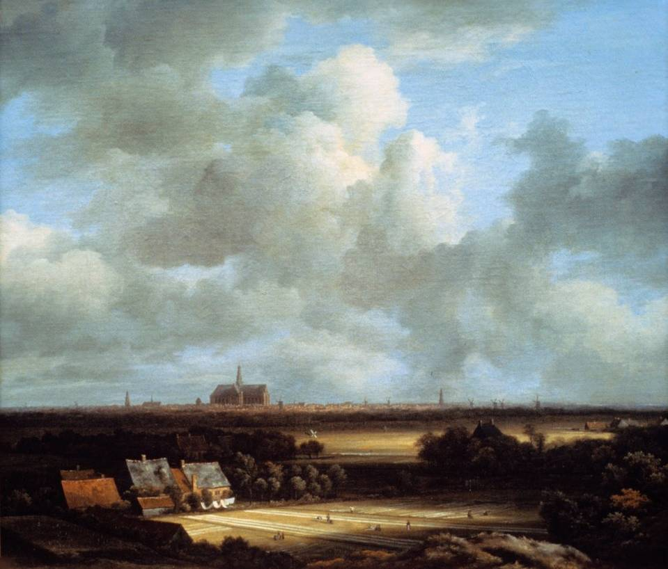

Jacob van Ruisdael, View of Haarlem, c. 1670

According to Ann Jensen Adams’ essay you read for module 8, landscapes are not simply accurate views of reality, but instead carry significance for the Dutch. Discuss how Ruisdael gives you a selective view of his hometown of Haarlem. What elements does he emphasize?

Question 3

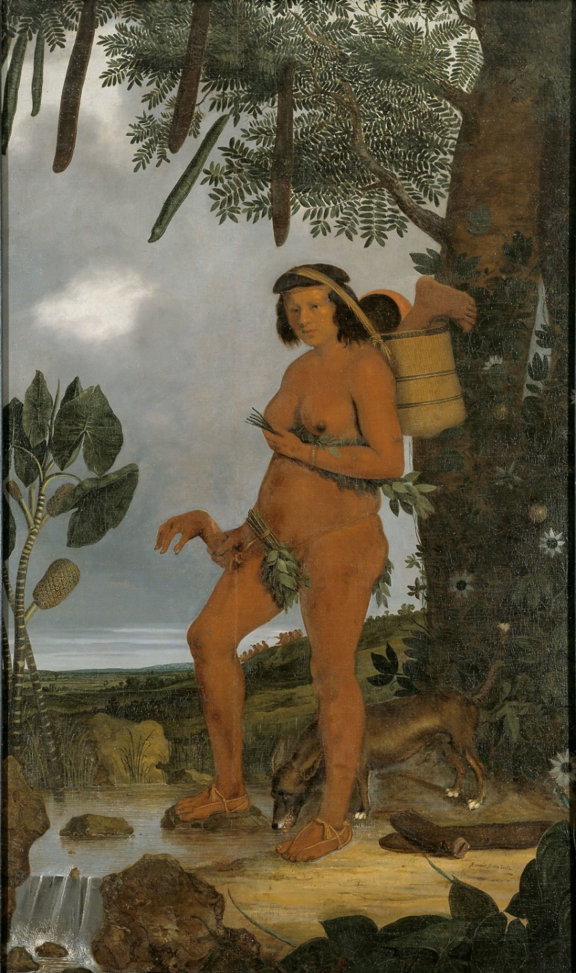

Albert Eckhout, Tapuia Woman, 1641

Explain the subject of the painting and where it was made. How did Eckhout portray the female figure, and what does it reveal about seventeenth-century Dutch attitudes towards the indigenous people of this land?

